Project Design Phase-II
Data Flow Diagram & User Stories

Date | 31 January 2025
Team ID | SWTID-2026-4717
Project Name | Al weather Wise
Maximum Marks | 4 Marks

Data Flow Diagrams:
A Data Flow Diagram (DFD) is a traditional visual representation of the information flows within a system. A neat and clear DFD can depict the right amount of the system requirement graphically. It shows how data enters and leaves the system, what changes the information, and where data is stored.
AI WeatherWise DFD
Example: (Simplified)
AI WeatherWise DFD: User provides location and weather-related requests → AI WeatherWise collects real-time data from Weather API and Location API → weather data is processed and stored → AI/ML model analyzes weather conditions → recommendation engine generates personalized forecasts, travel/activity suggestions and alerts → notification service delivers information to the user. User profiles, preferences and weather data are stored in cloud databases.

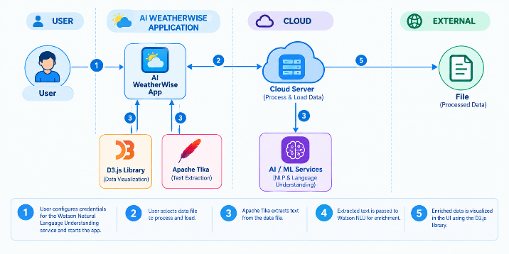

User Stories
Use the below template to list all the user stories for the product.
User Type | Functional Requirement (Epic) | User Story Number | User Story / Task | Acceptance criteria | Priority | Release
Customer (Mobile user) | Registration | USN-1 | As a user, I can register for the application by entering my email, password, and confirming my password. | I can access my account / dashboard | High | Sprint-1
 |  | USN-2 | As a user, I will receive confirmation email once I have registered for the application | I can receive confirmation email & click confirm | High | Sprint-1
 |  | USN-3 | As a user, I can register for the application through Facebook | I can register & access the dashboard with Facebook Login | Low | Sprint-2
 |  | USN-4 | As a user, I can register for the application through Gmail | OTP is verified and my account is created successfully. | Medium | Sprint-1
 | Login | USN-5 | As a user, I can log into the application by entering email & password | Valid credentials allow access to my account. | High | Sprint-1
 | Dashboard | USN-6 | As a user, I can log in using OTP. | A valid OTP allows me to access the application. | Medium | Sprint-2
Customer (Web user) | Dashboard | USN-7 | As a user, I can view the current weather for my location. | Temperature, weather condition, humidity, wind and rainfall information are displayed. | High | Sprint-1
 |  | USN-8 | As a user, I can view the weather forecast for upcoming days. | Hourly and daily forecasts are displayed correctly. | High | Sprint-1
Customer (Mobile user) | Location | USN-9 | As a user, I can select or search for a location. | Weather information is displayed for the selected location. | High | Sprint-1
 |  | USN-10 | As a user, I can use my current GPS location. | The application detects and displays weather for my current location. | High | Sprint-1
Customer (Mobile user) | AI Weather Assistant | USN-11 | As a user, I can ask AI WeatherWise questions about the weather. | AI provides a relevant and understandable response. | High
  Sprint-2
 |  |  | As a user, I can receive personalized weather recommendations. | AI provides recommendations based on weather conditions and user needs. | High | Sprint-2
  USN-12
Customer (Mobile user) | Weather Alerts | USN-13 | As a user, I can receive alerts for heavy rain, storms, and extreme weather. | Appropriate alerts are delivered to the user on time. | High | Sprint-2
 |  | USN-14 | As a user, I can customize my weather alert preferences. | Selected notification preferences are saved and applied. | Medium | Sprint-3
Customer (Web user) | Travel Planning | USN-15 | As a user, I can get weather-based travel recommendations. | AI provides travel suggestions based on forecast conditions. | Medium | Sprint-3
 |  | USN-16 | As a user, I can check whether an outdoor activity is suitable. | AI indicates whether the activity is suitable based on weather conditions. | Medium | Sprint-3
Customer Care Executive | User Support | USN-17 | As a support executive, I can view and respond to customer weather-service queries. | Customer queries can be viewed and responses can be provided. | Medium | Sprint-3
Administrator | User Management | USN-18 | As an administrator, I can manage registered users. | Administrator can view, update, or deactivate user accounts. | High | Sprint-3
Administrator | Weather Data Management | USN-19 | As an administrator, I can monitor weather data and API status. | Weather API status and data updates can be monitored. | High | Sprint-3
Administrator | System Monitoring | USN-20 | As an administrator, I can monitor application performance and errors. | System logs and errors are available for monitoring. | Medium | Sprint-3

